Genre Filtering

In order to produce a profitable movie, not to mention the kind of “most profitable”, we have to think about three factors: the popularity of the genre, the average profit ratio of the genre, and the consistency of the profit ratio of the genre. The first factor implies that the number of people would like to watch the movies; the second factor indicates the rate of return; the third factor serves as an indicator of risk, which could be considered as the risk evaluation factor.

Popularity

In terms of the popularity of the genre, it means that we have to produce a kind of movie in audience’s favor. In a general sense, we have to think about what the most popular genre is. In this case, we can just look at how the percentage of each genre falls into Top 100 in IMDB and changes over years.

*Dan Kopf, Priceonomics; Data: IMDB (due to the limitation of our scraped dataset, we are using this plot from outside source, but it aligns with our discovery in our data set as well, as you will notice in later discussion)*

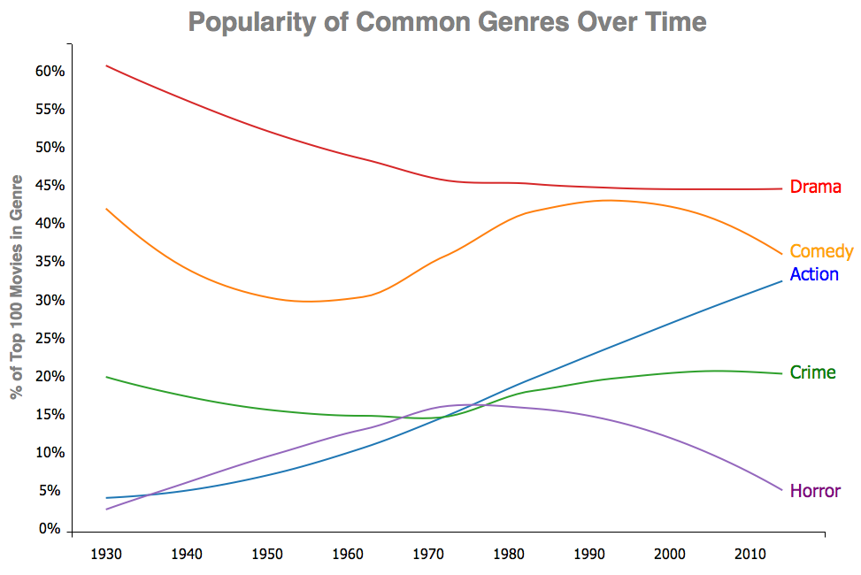

As we can see, dramas are gradually declining in popularity throughout the years. As the entertainment industry gets more diverse, the percentage of dramas available gets diluted. Nevertheless, dramas still play a major role these days. Dramas are running into a decreasing fashion because the majority of movies during the early last century were made of dramas, as the industry gets more diverse, the percentage of dramas gets diluted; nevertheless, dramas still play a huge role these days, as we will observe very soon. Secondly, the percentage of comedies is fluctuating over past eighty years and getting close with the Action for an obvious reason. Despite the trend of crime movies and the horror movies due to their deficiency in popularity (less than 20%), the action movie has been climbing not only steadily, but also substantially since the movie industry has emerged last century.

After closely looking into the dataset we collect, we found that most movies on IMDB fall into more than one genre. In fact, 83% of the films in our dataset are assigned to more than one genre; therefore, it is more appropriate to classify those action movies as movies with action on IMDB. As we randomly select some entries that are classified as action genre in our dataset as below: 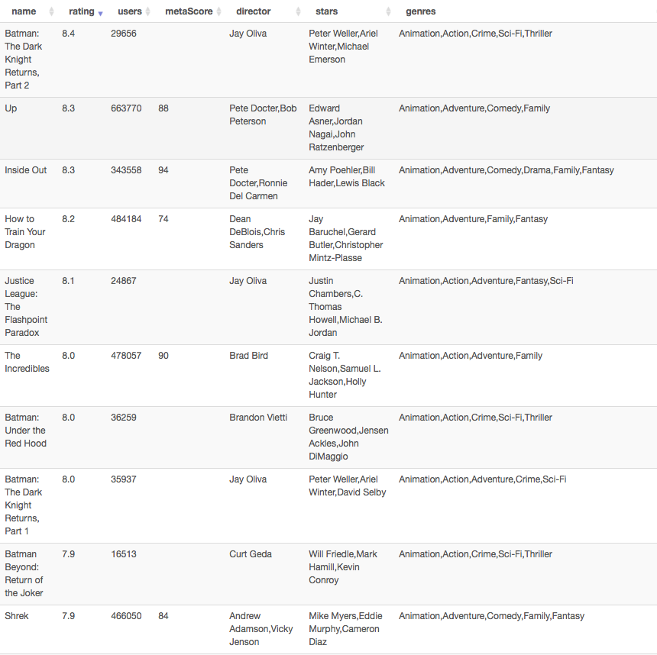

we realized that action movies are no longer “007 series”, “Mission Impossible”, Sly Stallone style action flicks, Jackie Chan's Chinese Kung Fu, or Jason Bourne Legacy nowadays. Instead, it is more like “Big Hero 6” and “Kung Fu Panda”, as part of the genre because there are some “actions” involved. The definition and the idea of the action movies have been evolving over decades. It is transforming into a more multiform combination rather than a singular condiment during the last decade. But why’s that? What makes action movies so special?

Profit Ratio

As we further researched for this specific question, hoping to draw some connection between profit and genres, we introduce a new variable called profit ratio. We define profit ration to be the gross budget ration in this case. Interestingly, we have found the answer lies within the change of the whole movie industry. To be more specifically, the change in target audience, audience expectation, and technology. The text of movies has been changed over time. First, to extend the range of potential audience, the media institutions and producers need to consider about the attraction of the movies to people from different races, genders, and social classes. For example, most action movies were violent and thrilling. To target at young audience, some animated action movies came out. For instance, Kung Fu Panda is one of those animated action movies, which involves the element of Kung Fu and also attracts young people. Furthermore, some women, who might be the decision makers in a movie dating, are not interested in action movies. Producers add romantic story lines to increase female audience’s utility of action movies. Meeting the target audience's preference is a way to make the action movies more profitable by increasing the demand.

The expectation of audience is the second factor that changes the text of both action and animation movies.  Since the rise of the movie field, audiences are familiar with the convention of different genres of movies. There has been a mind-set in audience’s expectation of new movies. However, people are also looking for fresh elements in movies, which could lead to considerable box office. Compared with other kind of genres, it is easier to make a breakthrough in action or animation movies because audience usually enjoy in the visual impact instead of the story line. As a result, more media institutions and producers chose to make action or animation movies. Keeping the audience’s curiosity could also make the movies profitable by making sequel. If people watched the first movie, they expected that the following-up movies have the same convention and are eager to watch the sequel due to their curiosity. As a result, the producer of the movie could focus on improving the visual arts, which people are excited about.

The third influence of the change of texts in both action and animation movies are technology.  Due to the significant development of technology, the cost of both action and animation movies becomes relatively lower. Currently, technology could substitute for some human resource, transportation, and propos. For instance, computers are necessary in movie production, which could function as digital media designers, VFX artists, who make special visual art for movies, and film cutters. As a result, the computers could save the spending on human resource. Seeing the huge profit in both actions and animation movies, more and more media institutions and movie producers turn to produce action or animation movies.

The expansion of target audience increases the demand of action and animation movies by meeting preference of people from different groups.  The audience expectations and technology motivates more producers to do action movies because of the easy way to meet people’s curiosity and the relatively low cost.  As a result, the action movies and the animation movies became wise choices for most movie producers.

Profit Ratio Consistency / Risk Evaluation

After the analysis and the research we did in previous two chapters, we have narrow down the whole genre list into a tuple, whether we should produce an action movie, or an animation movie? In order to make the best choice base on our analysis of the dataset we scraped, we now involves the third factor, the risk. From just comparing at the first and second figure rendered from our dataset, it appears that produce an action movie seems to be a wiser choice, but is that really the case?

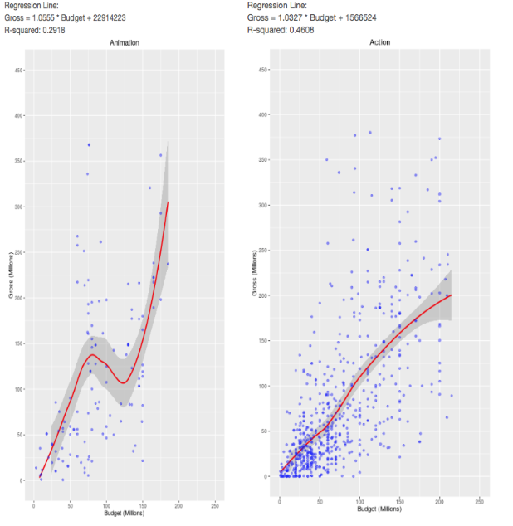

From just looking at the general trend, the action genre appears to be more stable than the animation genre in terms of the smooth line, which indicates a higher, more stable profit ratio. Nevertheless, by calculating the residue-square of the linear regression (not shown in graph for simplicity, but numbers are given for reference), we also noticed that in action genre, gross and budget actually has higher residue-square, in another word, budget and gross has more correlation in action genre than in animation genre.

Although in general, action genre has better profit ratio and profit trend, we should not jump into the conclusion that making action movies is profitable for sure. After all, there are still tons of action movies lose money all the time. Under this consideration, we decided to involve another variable, the standard deviation of the profit ratio of each genre. An intuitive way to interpret this variable would be the probability of following the original profit ratio slope.

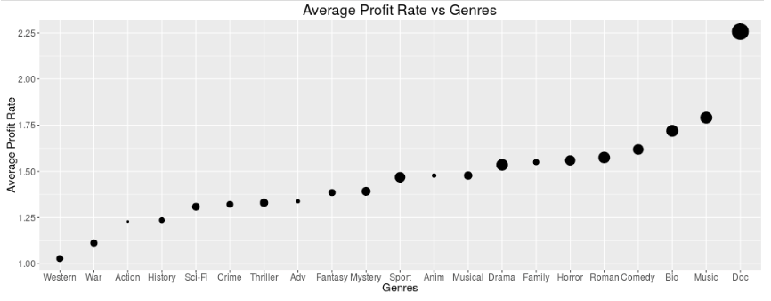

In the above figure, the size of the dot represents the standard deviation, the bigger the dot is, the larger standard deviation. What does a larger standard deviation mean? Is it a good thing? As we can see, the dot that represent action genre is obviously smaller than the animation genre. It is bad? No. It is not. A standard deviation implies the stability of following the profit ratio trend in that specific genre. The larger standard deviation we have, the movie we produce is less likely to follow the general profit ration trend of that genre. To sum up in one word, it’s not only less risky to invest in action genre rather than animation genre, but also the rate of return is more consistent.

Timing

After the genre is determined, we decided to play with our dataset to see if there are any less intuitive factors would contribute to the profit ratio, so that we can take advantage of this factors by fixed the variables in our favor. Interesting, we did have some discovery relates to the timing when we release the movie. However, funny enough, it is very random and hard to come up with a reasonable explanation. Our discovery relates to release timing lies into below two figures.

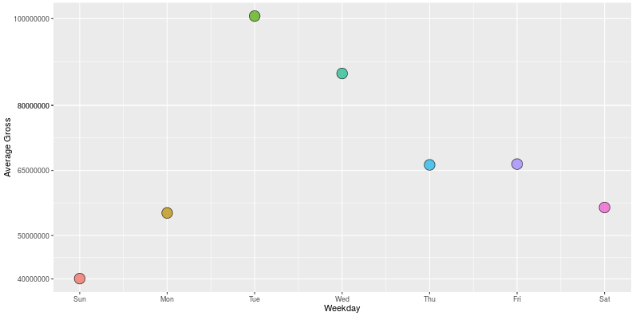

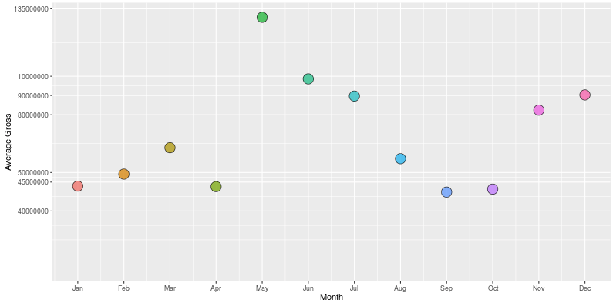

As the figures explicitly describe, there is huge difference in gross between both days of week and months. The second figure clearly shows that releasing the movie in May is the way to go. The logic behind it is quite straightforward, May is when the summer break starts, which further implies that the majority of audience are students. This is important, as we have discussed in the popularity section, the majority of students prefer action movie to others. On the other hand, releasing movie in January or September is a bad idea due to the fact that the school has just begun and lives of students are overwhelming. Nevertheless, week of the day is another timing factor that hugely impact the gross of the movie. According to the figure we rendered from our dataset, Tuesday is the winner. It is very hard to come up with an explanation of why Tuesday is the best choice in this regard since we don’t have other variables in our dataset that can incorporate with the timing data. Which is one of our limitation in our research, but not necessary the limitation of getting us what we want, which is to find out the way to produce the most profitable movie.